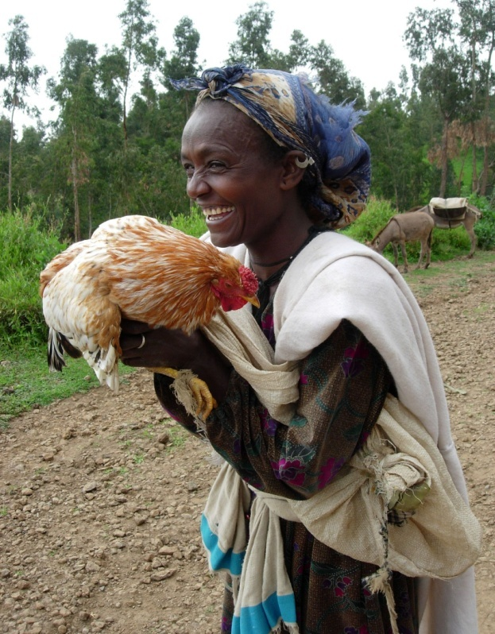On Happiness, Freedom, and Unleashing the Power of the Market

by

Eleni Z. Gabre-Madhin

IFPRI

Chief of Party, ECEX Project

Speech delivered at TEDGlobal Conference on “Africa: the Next Chapter”

Arusha, Tanzania

June 5, 2007

Good morning TED! It is a great delight to be here.

There is a quiet kingdom nestled among the Himalayas, where the people of Bhutan are trying a novel idea, to measure their Gross National Happiness instead of their Gross National Product. And why not? After all, the pursuit of happiness can be considered not just a luxury for the advantaged, but a fundamental human right of all.

And what is it to pursue happiness?

It is about the freedom of choice. Freedom… to choose where to live, where to work, what to do or not to do, what to sell, what to buy, to whom, when, and how.

And what is choice?

Choice depends on the availability of choices.

And where does choice come from? And how is it expressed? And who gets to express it?

One means of expressing choices is through markets.

Well-functioning markets provide choices and, ultimately, enable the expression of the freedom to pursue one’s happiness. The great Indian economist, Amartya Sen, was awarded a Nobel Prize for demonstrating that famine is not about food availability but rather about one’s ability to acquire that food. In 1984, in what can only be considered among the greatest crimes of humanity, one million people died of hunger in the northern regions of my country of birth, Ethiopia, even while a surplus of food actually existed in the fertile southern regions. That realization was a turning point for my life.

Most Africans today, by far, are farmers. And most of Africa’s farmers are small farmers in terms of land and very, very small farmers in terms of the capital they have at their disposal. African agriculture is today one of the most undercapitalized in the world. Only seven percent of arable land is irrigated, compared to 40 percent in Asia. Our farmers apply 22 kg of fertilizer per hectare on average compared to 144 kg in Asia. The number of tractors is three times greater in Asia and eight times greater in Latin America than in Africa. Road densities are more than 2.5 times higher in Latin America and 6 times higher in Asia than in Africa.

The small farmer today in Africa lives a life without much choice and therefore without much freedom. His livelihood is pre-determined by the conditions of grinding poverty. He sells the fruits of his hard labor when prices are lowest just after harvest because he has no choice. Later in the year, come the rainy season which we call the “lean” season because food is scarce and prices are highest, she buys to feed her family because she has no choice. And most African farmers are in fact outside of the market altogether, producing just enough or not enough for their own survival, neither buying nor selling in the market at all, because that choice itself does not exist.

The real question is: How can markets be developed to harness the energy of the individual farmer’s drive for innovation and entrepreneurship? Another notable economist, Theodore Schultz, was awarded a Nobel Price in 1974 for proving that farmers are poor but efficient, that is, that farmers are rationally profit-oriented, and want to make money just like everyone else! We no longer need Nobel Prizes to show that farmers want a fair shake at the market, because if one thing is clear, it is that Africa IS open for business, *and* that agriculture is business.

Over two decades ago, the world insisted to Africa that markets must be liberalized, that economies must be structurally adjusted. That meant that governments were to remove themselves from the business of buying and selling, rather inefficiently, and let the private market do its magic. What happened? Did Africa feed itself? Did African farmers transform themselves into highly productive commercial actors? We in this room are probably here because we know that, to the contrary, sub-Saharan Africa is the only region of the world where hunger and malnutrition are projected to go up over the next ten years, where the food import bill is now double what it was 20 years ago, where food production per capita has remained the same and where fertilizer use has gone down instead of up.

Why didn’t agricultural markets perform to expectations? The market reform prompted by the West, with all the best intentions, seems to have thrown the baby out with the bathwater. Like its agriculture, African markets are under-capitalized and inefficient. They are characterized by high costs and high risks of transacting, forcing much of the continent into global isolation. Only one third of agricultural output actually reaches the market. In addition to weak road and telecommunications infrastructure, the market suffers from a virtual absence of necessary market institutions, such as market information systems, product grading and certification, and ways to reliably connect buyers and sellers. Because of this, commodity buyers and sellers reduce their risk and costs by trading only with those they know. Trade is done on the basis of visual inspection because there is no assurance of product quality or quantity, which drives up marketing costs, leading to high consumer prices. For their part, small-scale farmers, who produce the bulk of agricultural output, come to market with little information and are at the mercy of merchants in the nearest and only market they know, unable to negotiate better prices or reduce their market risk.

Price volatility of food crops in Africa is likely the highest in the world. And our small farmers bear the brunt of that market risk, in a way that no farmers in any other region of the world or in any period of history have had to face. I am convinced that no country or region could grow its agriculture with this kind of risk.

For example, in Ethiopia, the variation of prices for maize from one year to the next is in the order of 50 percent. This is mind-boggling. This kind of market risk has direct implications for both the incentives of farmers to invest in achieving higher productivity as well as for food security for the country. Between 2001 and 2002, Ethiopian maize farmers had successfully produced two years of bumper harvests. This led to a collapse of prices by up to 80 percent. In the grain belt of the country, prices fell so low that some farmers did not even harvest some 300,000 tons of grain from the field, because it was not profitable. Less than six months later, that very same year, when the rains failed in other parts of the country, Ethiopia announced a major food crisis and the need for emergency food to avert starvation for 14 million people. At the same time, farmers who had been hit by the collapse in prices reduced their fertilizer use by 27 percent for the following year. This is an example of “arrested development”, or a budding Green Revolution stopped in its tracks. And this is not unique to Ethiopia, but happens over and over again all over Africa.

But I am not here to wring my hands or to lament the past. I am here to tell you that change is in the air. Africa today is not the Africa that is waiting for aid solutions or foreign cookie-cutter policy experts’ prescriptions. Africa is learning, though perhaps too slowly, that markets don’t just happen by themselves. In the 1980s, it was fashionable to talk about “getting prices right,” which was mainly about getting governments out of the market. We now recognize that unleashing the power of the market is about getting markets right, which involves investing in the right infrastructure and developing the necessary market institutions. When conditions are right, we are seeing that the power of innovation is alive and ready to explode in Africa just like anywhere else.

Nearly three years ago I decided to leave my comfortable job as a World Bank senior economist and return to my country after 30 years abroad. I went for a simple reason. Having spent more than a decade studying and writing and convincing policymakers and even donors about market problems in Africa, I decided it was time to do something about it.

In Ethiopia, I am leading an exciting new initiative to establish the first organized marketing system, the Ethiopia Commodity Exchange, or ECEX. The commodity exchange concept itself is not new. The very first and most well known organized commodity market was established in 1848 by 82 grain merchants and farmers in a little town at the crossroads of the Illinois river and Lake Michigan, known as Chicago. The Chicago Board of Trade was then established for the very same reasons that our Ethiopian farmers today would benefit from a commodity exchange. Farmers in the American Midwest would load their grain on a barge and take it up river to the Chicago market. However, once arrived, if they could not find a buyer or if prices suddenly fell, they would incur huge losses and even dump it in Lake Michigan rather than spend more money taking it back home. The need to avoid these tremendous risks led to the birth of the futures market and the underlying system of grading the grain and issuing a warehouse receipt to certify the product quality and quantity. From there, the greatest innovation came about: buyers and sellers could buy and sell goods without having to visually inspect the grain. That meant that grain could be traded across great distances and even across time, as far as 18 months into the future. This innovation is at the heart of the transformation of American agriculture and the rise of Chicago from a regional market to a global market center for agriculture.

Over the last century, commodity exchanges and the global reference prices they provide have traditionally been associated with major cities such as London, Chicago, New York, and Tokyo. But over the last decade, this has begun to shift. And this is due to the power of technology and the shifting of market dominance to the emerging markets. Powered by information technology, we are seeing the rapid growth of developing country exchanges in which many small actors are able to participate in the market. Over the last decade, the share of Western organized exchanges in the world has fallen by half. In 2004, the Dalian Commodity Exchange in China overtook the Chicago Board of Trade to become the second largest commodity exchange in the world and is becoming the global reference price for soybeans. In India, two national commodity exchanges established just 3 years ago are growing at phenomenal growth rates above 270 percent a year and have grown to trading more than a $1 billion of contracts a day, where farmers now use the futures prices to guide their planting decisions. Despite these global trends, a world map of commodity exchanges would show a rather big blank over the African region, where exchanges are yet to emerge with the notable exception of South Africa.

In Ethiopia, our commodity exchange is uniquely designed to meet Ethiopia’s needs and conditions. We are not trying to cut and paste the Chicago or India model but rather to create a system that works for Ethiopia’s reality. ECEX is an Ethiopian Exchange for Ethiopia. Thus, we are creating what is perhaps the first such system uniquely designed for the needs of small farmers. We are creating a system that serves all market actors, that goes well beyond agriculture itself and that will serve as a catalyst for transforming our ICT sector, our financial sector, and even changes in the legal framework.

This integrated perspective is what we call the ECEX Edge. The ECEX Edge recognizes that, up to date, efforts to improve the market have been piecemeal and patchy. Thus, one donor or NGO focuses on market information, another on grades and standards, another on warehousing, and yet another on ICT.

Our ECEX design is based on an integrated development of all the pieces of the puzzle that will make the market work. Thus, we have a design in which the Exchange will operate warehouses throughout the country, where commodities are graded, weighed, and certified, in order to guarantee the integrity of the product. The ECEX trading system combines a physical trading floor located in Addis Ababa, where buyers and sellers may participate in “open outcry” bidding for commodities, alongside electronic remote access to the trading system. To bring security to the market and enable greater market participation, ECEX guarantees payment against delivery through an internal clearinghouse system, in partnership with clearing banks. Finally ECEX operates an in-house commercial arbitration mechanism to settle disputes as efficiently as possible.

Alongside that, ECEX will operate an electronic price dissemination system in 200 rural district sites so that farmers will see in real time the market prices that are being discovered in the Addis Ababa market. This fundamentally changes the relationship of farmers to the market. Whereas farmers usually think local, with the local market being the nearest rural market located on average some 10 to 12 kilometers away, now our farmers think national and even global. Farmers who brought product to market without any idea of the market premium available for different qualities now have an incentive to add value to their product. Farmers who brought product to market at harvest now at the lowest price can use futures prices as a guide not just for their marketing strategy but also even for their planting decisions. Thus, our farmers start the evolution from subsistence farming to a commercial orientation, based on information and access to a national market platform.

Our rural and regional traders also transform from “back-to-back” trading based on very limited arbitrage and limited finance to more strategic trading that is able to get food surpluses from producer areas to deficit areas in the country more quickly and at lower cost. Our exporters and processors can use the futures market to lock in supply and quality and achieve better planning and production horizons.

Can Ethiopia do it? This initiative requires great political will to align the financial sector in a country where financial institutions are just waking up, to harness information technology in a country with weak infrastructure, to create new laws and a regulatory environment.

The winds of change are here. At present, there is a great momentum on the part of both the government at the highest level and the private sector, from farmer groups all the way to industrial actors. ECEX is the market for Ethiopia’s new Millennium, which starts in late 2007. The last Parliament of our century opened last October with the President announcing that this initiative is the country’s top economic priority for the next year. The stakes are high, and the returns will be even higher.

Can Ethiopia do it? We believe it can be done. We say Yichalal!, it can be done, following the tradition of our great runner, Haile Gebreselassie. Moreover, ECEX paves the way for a pan-African trading platform. ECEX positions Ethiopia as a regional market player, adding significant value to its $1 billon domestic market, in which Ethiopia is Africa’s second largest maize producer, with total grain production 30 percent higher than South Africa. ECEX enables our farmers to connect to consumers of our pulses and sesame seed in the huge and growing markets of India and China, as well as Europe. If ECEX can capture even 40 percent of the current domestic market and raise commercialization by farmers by just 25 percent, this doubles the value of the domestic market.

By creating meaningful choices and transforming the lives of Ethiopian small farmers, we believe that ECEX is an outstanding value proposition to Ethiopia’s future and that the sky is the limit.

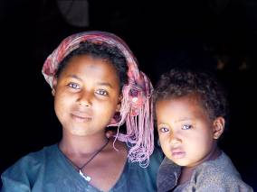

*ECEX. A winning value proposition…*

*to transform farmers’ choices*

*empower market actors*

*and change Africa.*